Practical - 2
Practical Title: Semantic HTML5 Pages with Accessibility-Ready Structure

Develop static HTML5 skeletons for at least 10 StudentHub pages such as Home, About, Register, Login, Dashboard, Events, Profile, Contact, Admin, FAQ, and Feedback. Use semantic tags and accessibility-friendly structure.
Theory1. Are semantic tags such as header, nav, main, section, article, aside, and
footer used properly?

1. Are semantic tags such as header, nav, main, section, article, aside, and
footer used properly?
Semantic tags should be used properly because they give meaningful structure to an HTML page and improve readability, accessibility.
<header> – introductory content, logo, or page heading.
<nav> – navigation links/menu.
<main> – the main unique content of the page.
<section> – groups related content.
<article> – independent, self-contained content such as a post or news item.
<aside> – related or supplementary content, usually a sidebar.
<footer> – bottom section containing copyright, contact information, or additional links.
Reference Link: HTML Tags - A to Z List - GeeksforGeeks

2. Are form labels, headings, image alt text, and navigation links
accessible?
A website is considered accessible when users, including people using screen readers or keyboard navigation, can understand and use its content.
- Form labels: Each input should have a clear <label> connected to the input using for and id. This helps users understand what information to enter.
- Headings: Use headings in a logical order, such as <h1> for the main heading and <h2> for sections. This helps screen-reader users navigate the page.
- Image alt text: Images should have meaningful alt text describing their purpose. It helps screen-reader users and provides information when an image cannot load.
- Navigation links: Use clear, meaningful link text and semantic <nav> elements so users can understand and navigate the website easily.

Reference Link: HTML Tags - A to Z List - GeeksforGeeks

3. Is the page structure consistent across all pages?
Yes, the page structure should be consistent across all pages. Common elements such as the header, navigation bar, main content area, and footer should follow the same structure, while the main content can change for each page
Reference Link : HTML Tags - A to Z List - GeeksforGeeks

Implementation/ Output/Result

My learning codes: https://drive.google.com/file/d/1CPP3uUq3gdKZxC3pFB7iheZVU7FCImSx/view?usp=drive_link

Evidence of Work (Screenshots)
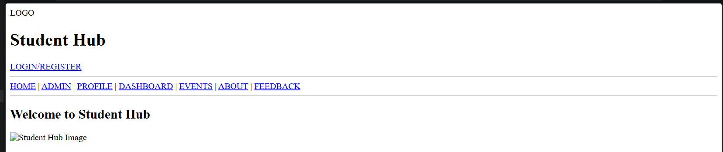Description:
This is the Student Hub Home Page, which provides the main entry point to the website. It includes the Student Hub logo/title, login/register option, navigation links, a welcome message, and a main image section.
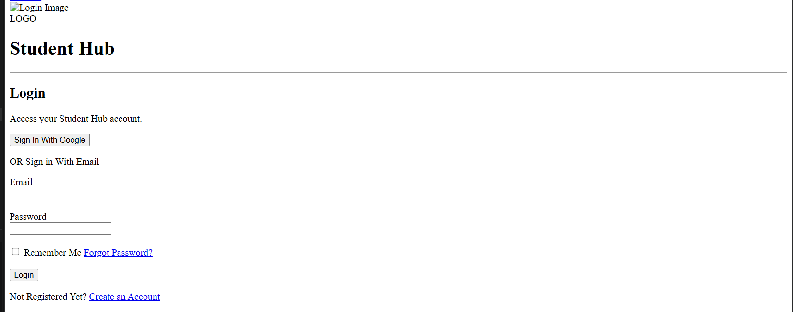
Description:
This is the Student Hub Login Page, designed for registered students to access their accounts. It provides Google/email login options, email and password fields, a “Remember Me” option, password recovery, and account registration links.
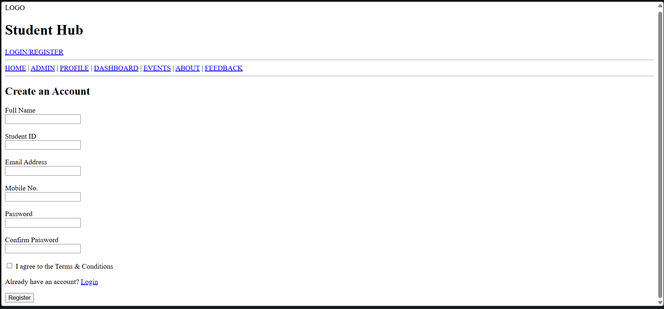Description:
The Register page allows new students to create a Student Hub account by entering their personal and student details, including name, Student ID, email, mobile number, and password.
It also includes Terms & Conditions confirmation and a link for existing users to log in.

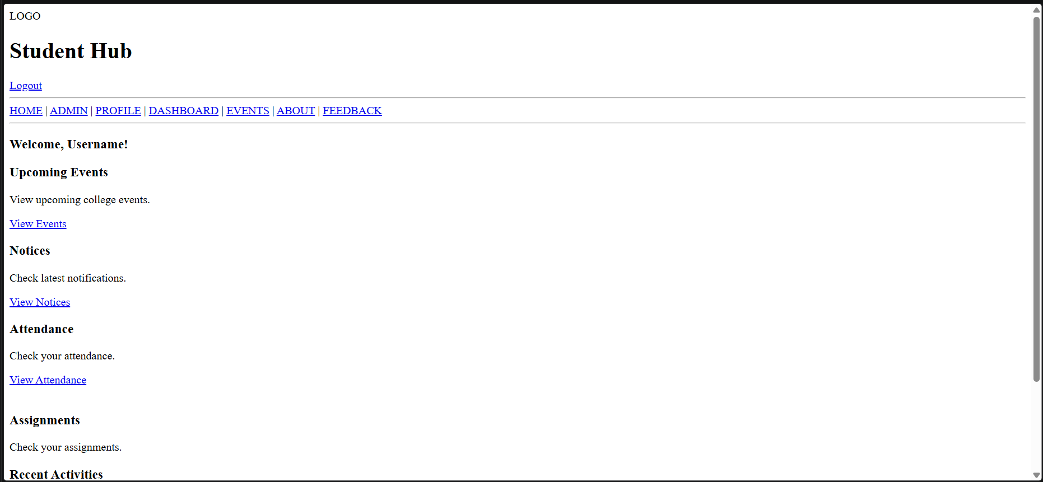
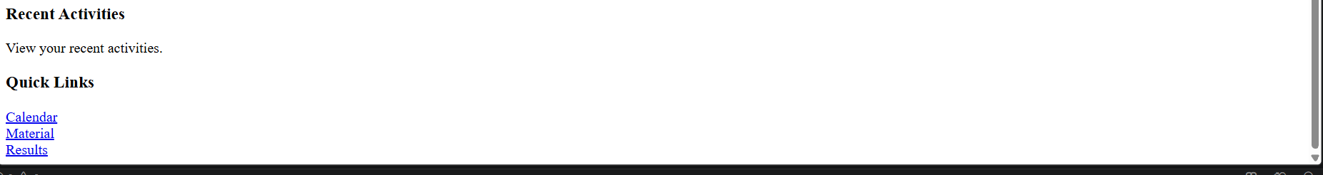Description:
The Dashboard page provides a central overview of the student's academic activities, including upcoming events, notices, attendance, and assignments.
It also provides quick links to the calendar, study materials, results, and recent activities.
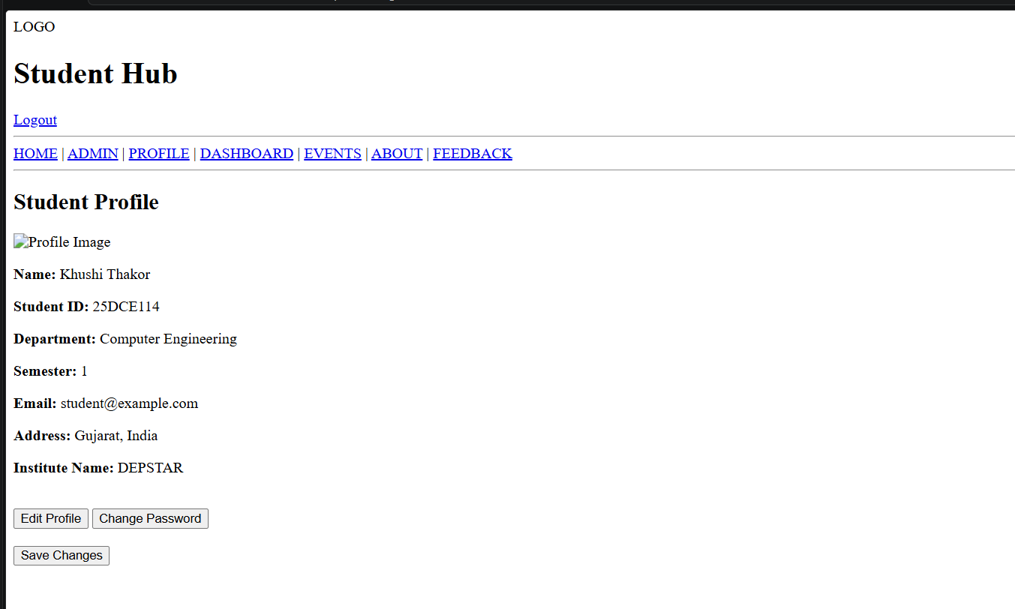
Description:
The Profile page displays the student's personal and academic information, including name, student ID, department, semester, email, and institute details.
It also provides options to edit the profile, change the password, and save updated information.
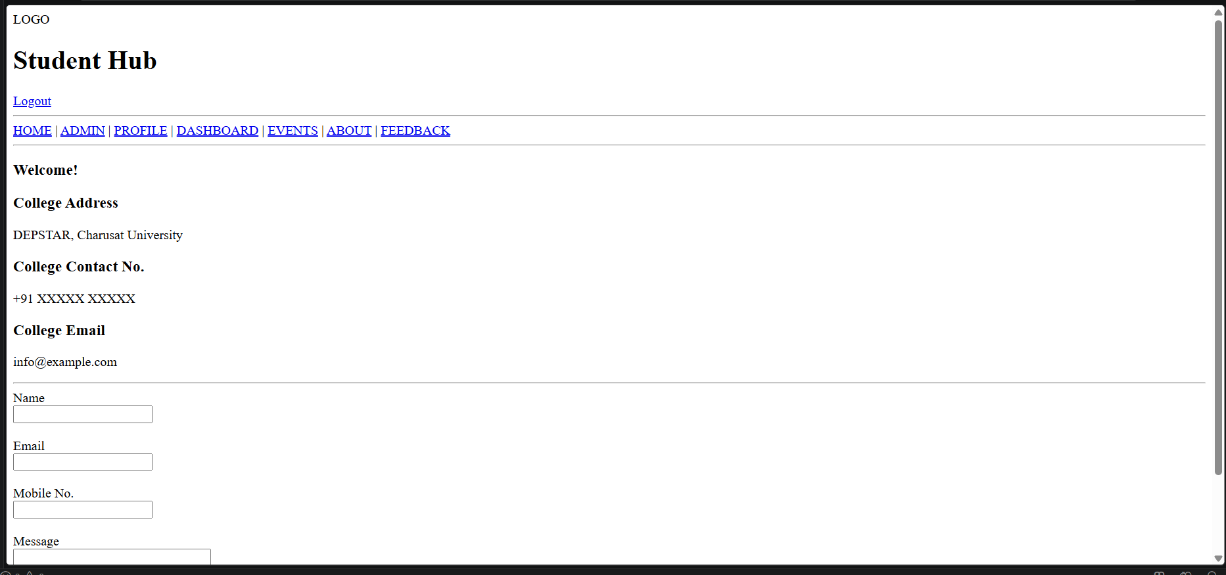
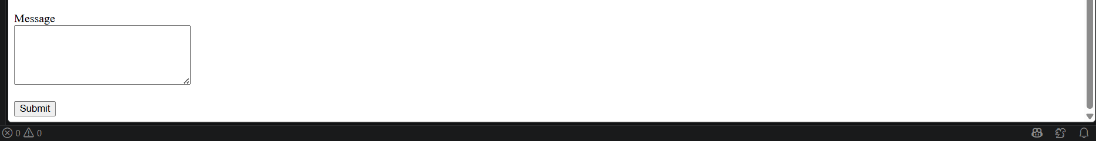Description:
The Contact page provides the college's address, contact number, and email for communication. It also includes a contact form where students can enter their name, email, mobile number, and message to submit an inquiry.
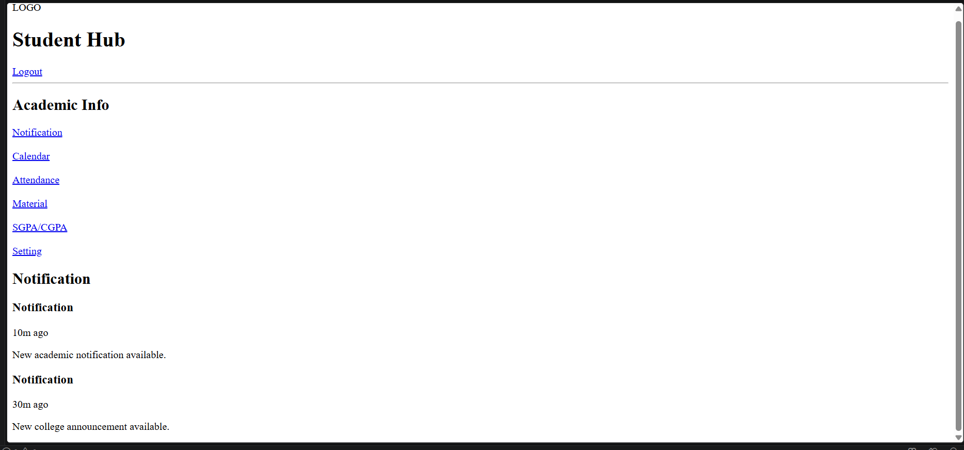
Description:
The Notification page displays important academic and college announcements for students, along with the time of each notification. It also provides an Academic Info sidebar with links to Notification, Calendar, Attendance, Material, SGPA/CGPA, and Settings.
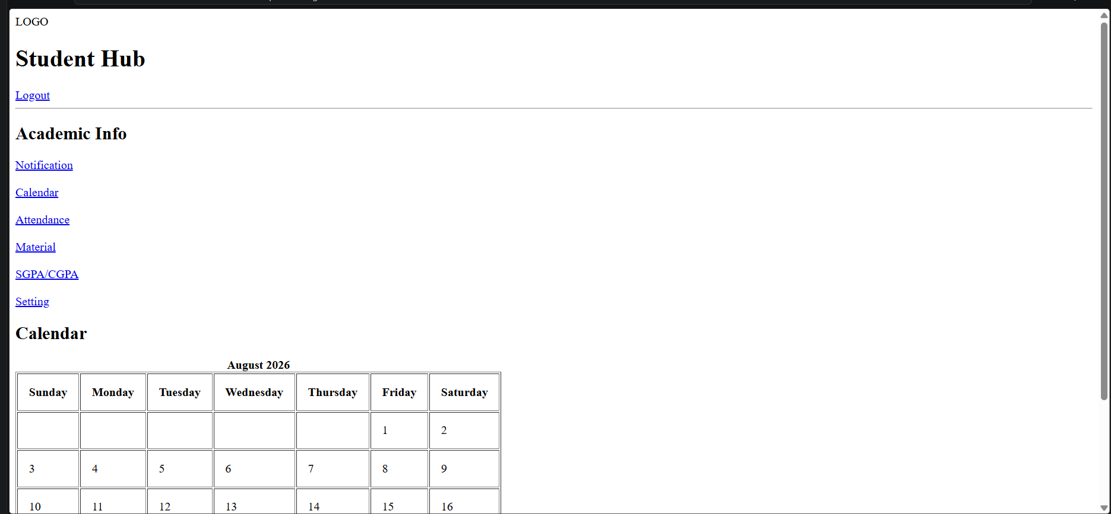
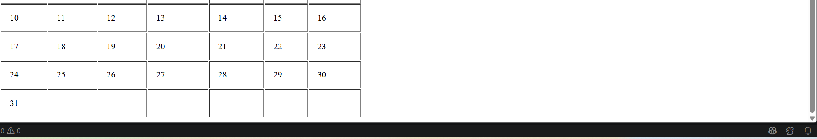
Description:
The Calendar page displays the August 2026 academic calendar in a structured monthly format, making it easy for students to view dates and plan their activities. It also includes an Academic Info sidebar with quick links to Notifications, Calendar, Attendance, Material, SGPA/CGPA, and Settings.
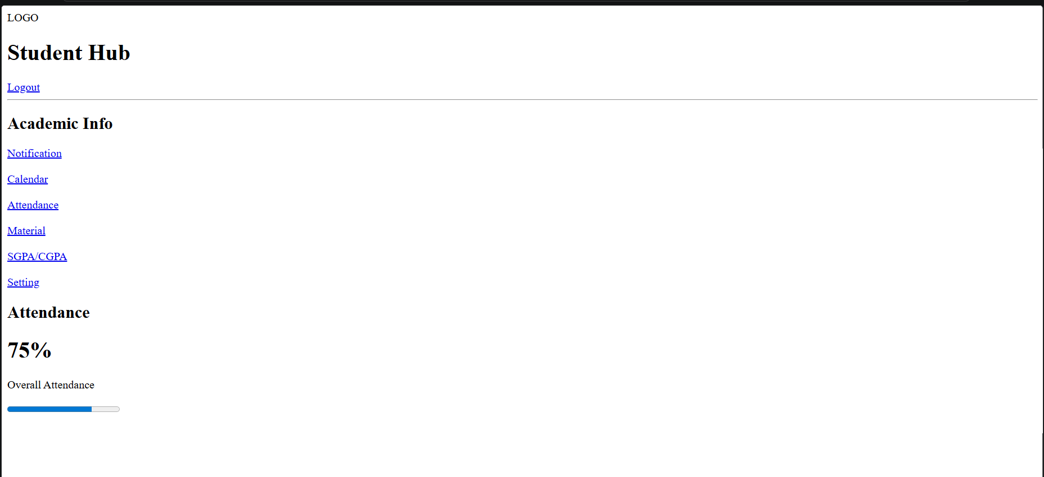
Description:
The Attendance page displays the student's overall attendance percentage along with a progress bar for easy understanding. It also includes an Academic Info sidebar with links to Notifications, Calendar, Attendance, Materials, SGPA/CGPA, and Settings.

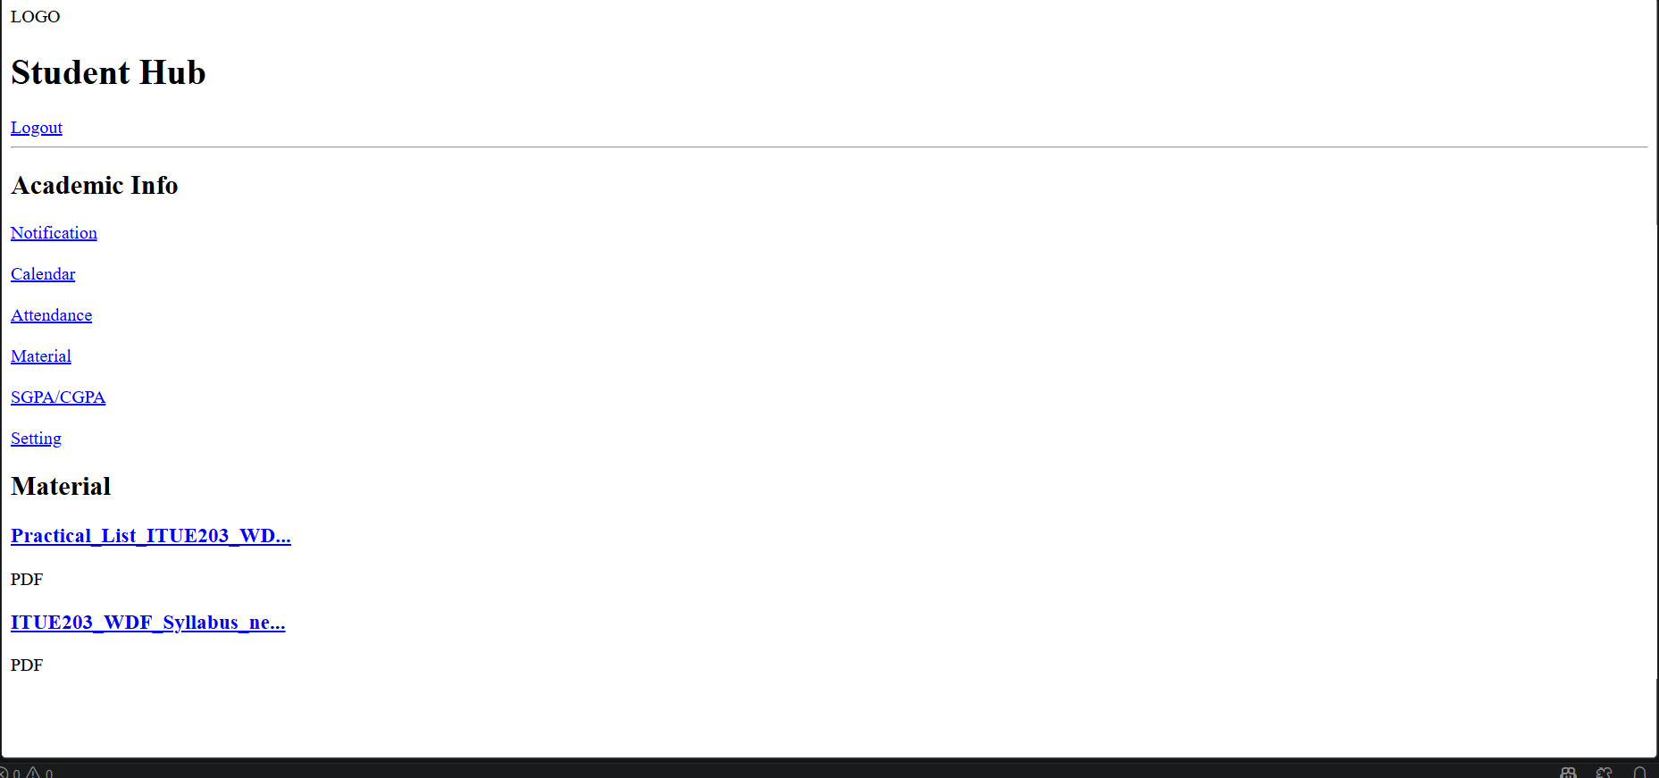Description:
The Material page provides students with access to important academic study materials, such as practical lists and course syllabi in PDF format. It also includes an Academic Info sidebar for quick navigation to notifications, calendar, attendance, results, and other academic sections.
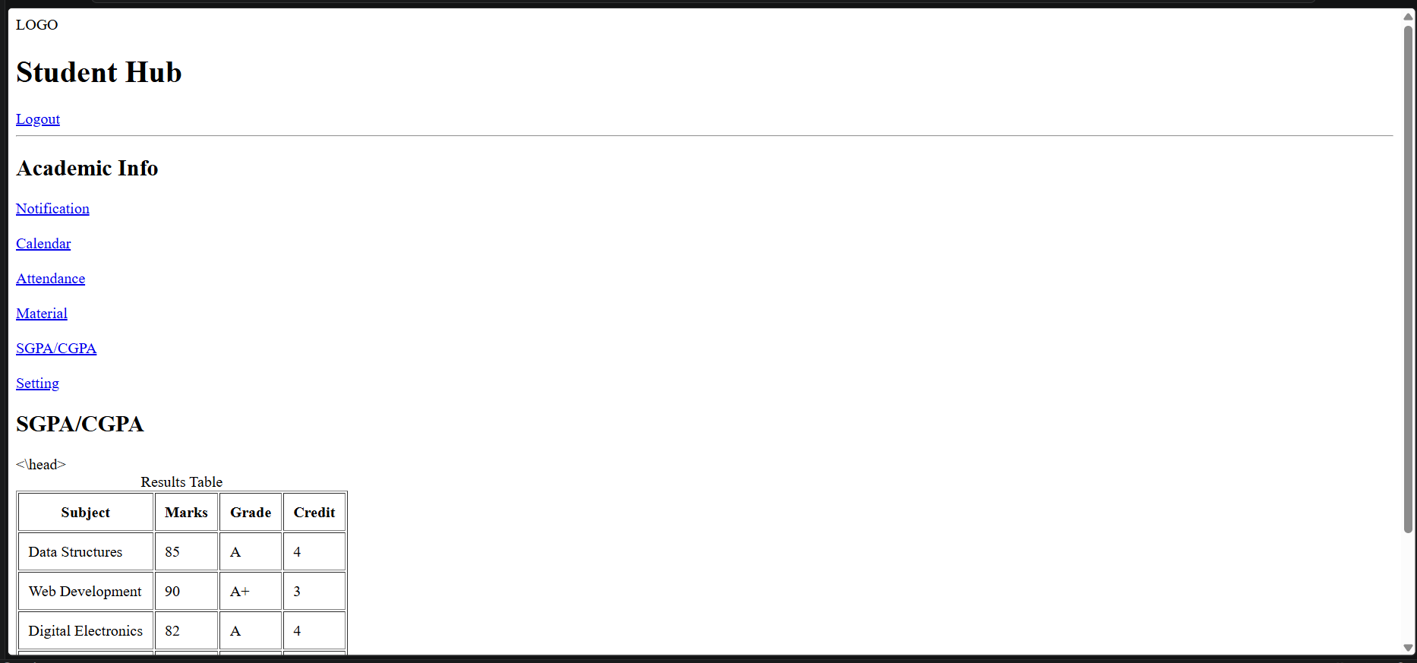
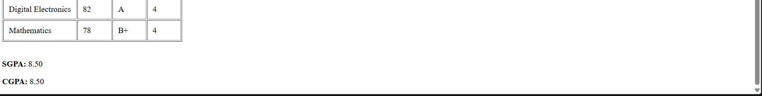

Description:
The Result page displays the student's subject-wise marks, grades, and credits in a structured results table. It also shows the student's SGPA and CGPA, along with an Academic Info sidebar for accessing other academic sections.
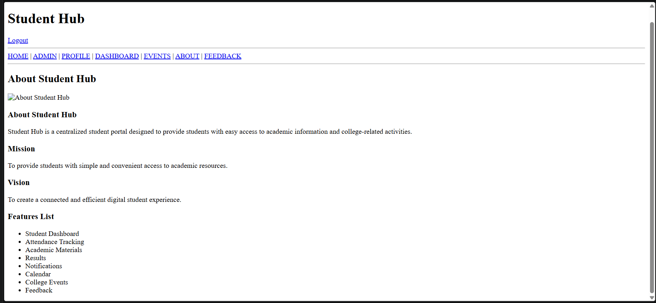
Description:
The About page introduces the Student Hub platform and explains its purpose as a centralized portal for academic information and college activities.
It also presents the Mission, Vision, and key features such as attendance, materials, results, notifications, calendar, events, and feedback.
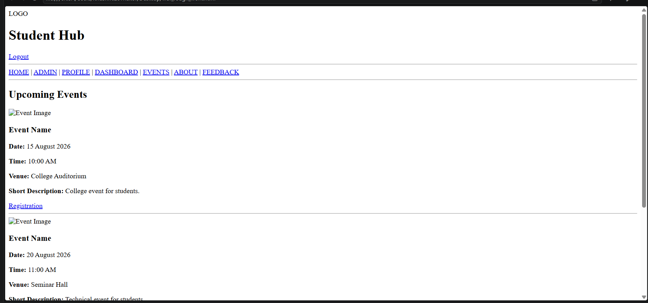
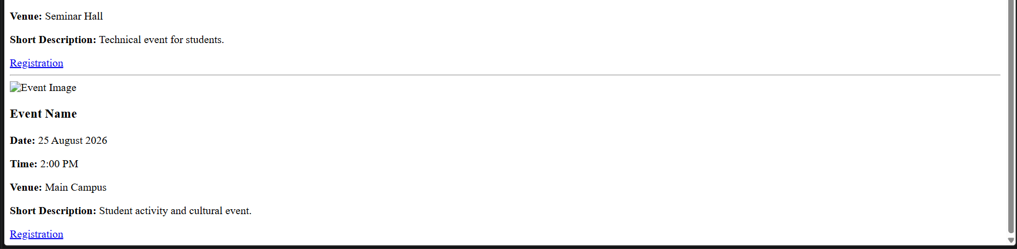
Description:
The Events page displays upcoming college events with their date, time, venue, and short description. Each event also includes an image and a registration option, helping students easily view and participate in campus activities.
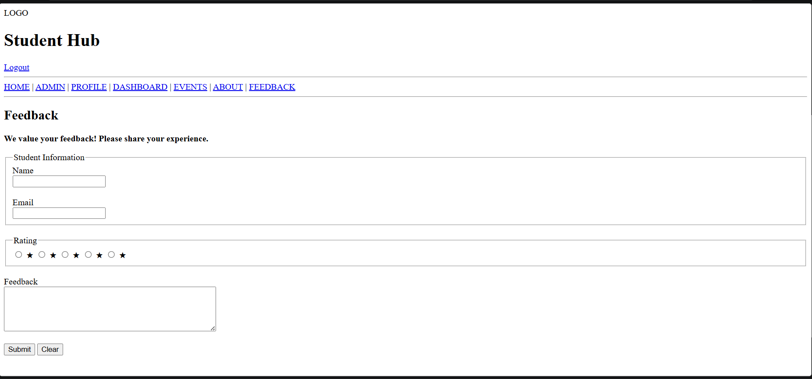
Description:
The Feedback page allows students to share their experience by providing their name, email, rating, and written feedback. It includes Submit and Clear buttons to send the feedback or reset the form.
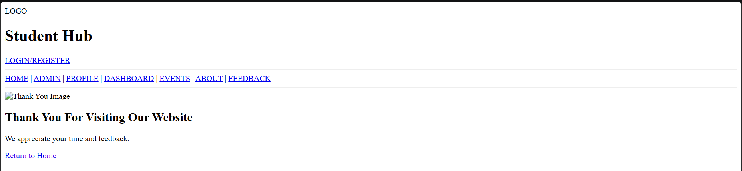
Description:
The Thank You page confirms that the user's visit or feedback has been successfully received and displays a thank-you message.
It also provides a Return to Home link so users can easily navigate back to the Student Hub homepage.

GitHub Repository Link:
Khushi-Thakor2007/Student-Hub-Portal

Challenges Faced:
The problem which I faced while making my html pages is which tag is appropriate for the particular event. Like , div tag is better then table tag.

Learning Outcomes:

Students will create clean, linked, and accessibility-ready HTML page structures.

Faculty Remarks:

